**[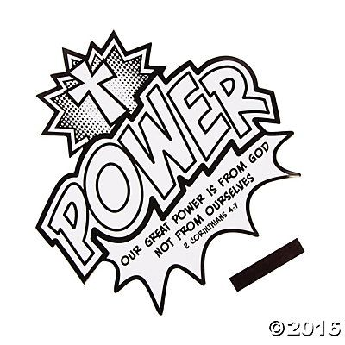](http://www.orientaltrading.com/color-your-own-power-is-from-god-cutout-magnets-a2-13733295.fltr?Ntt=vbs%20preschool%20crafts)**