**[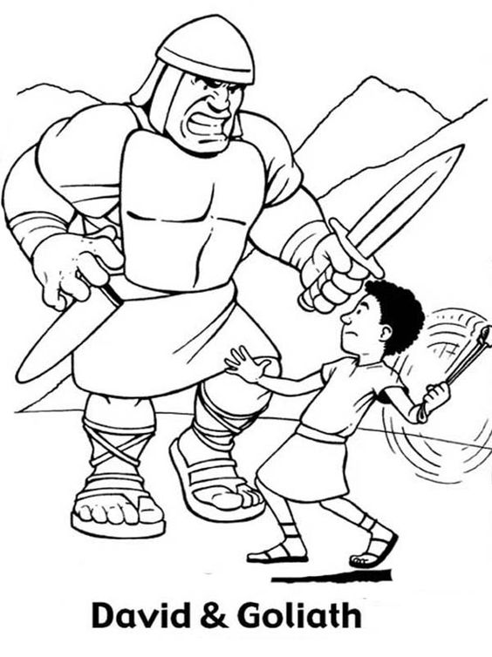](http://www.netart.us/great-battle-david-versus-goliath-in-the-bible-heroes-coloring-page/)**