**[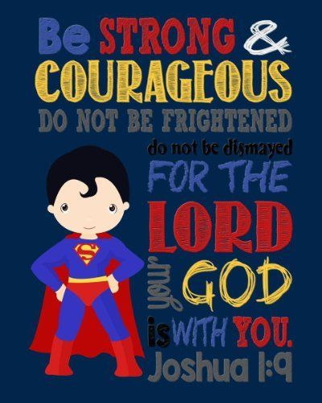](http://www.amazon.com/Super-Hero-Wall-Art-Courageous/dp/B017E4MGNI/ref=sr_1_135?m=AO3NL33JDBNXF&s=handmade&ie=UTF8&qid=1447683917&sr=1-135)**