Golden Calf

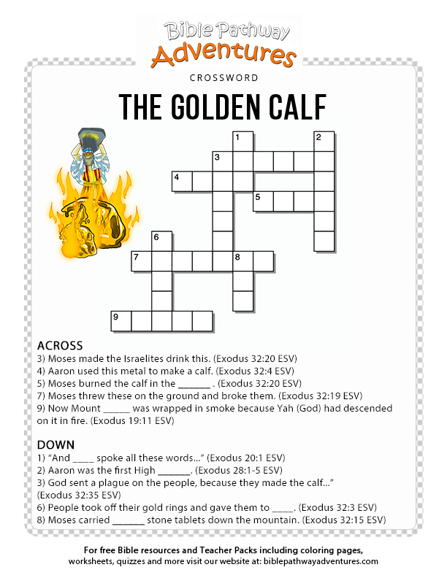

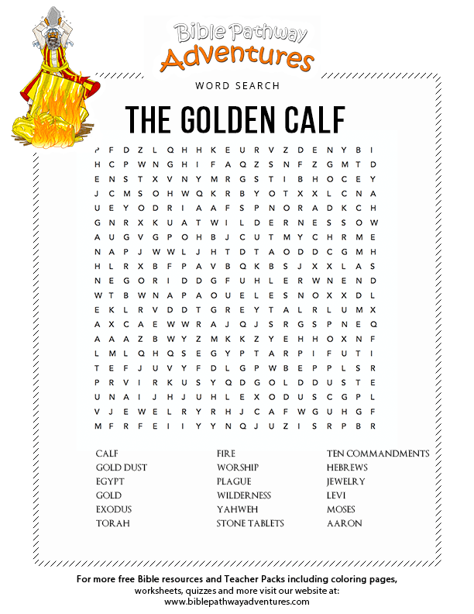

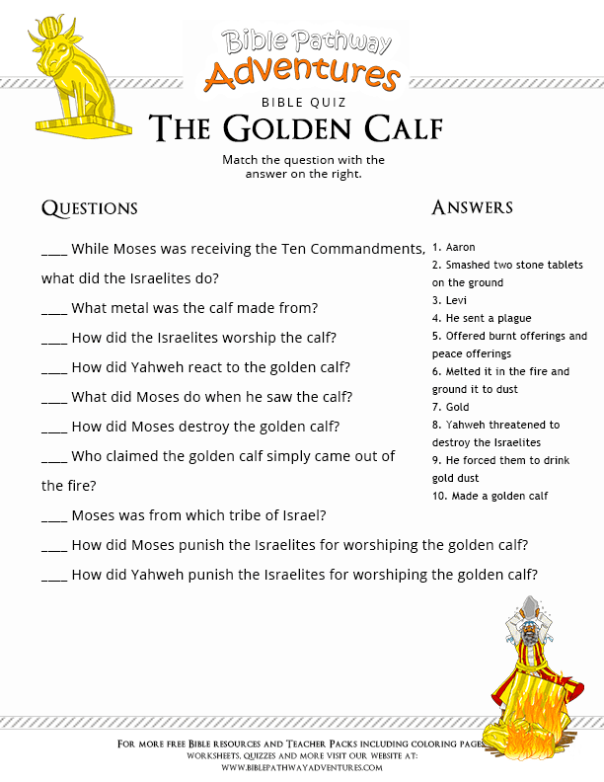

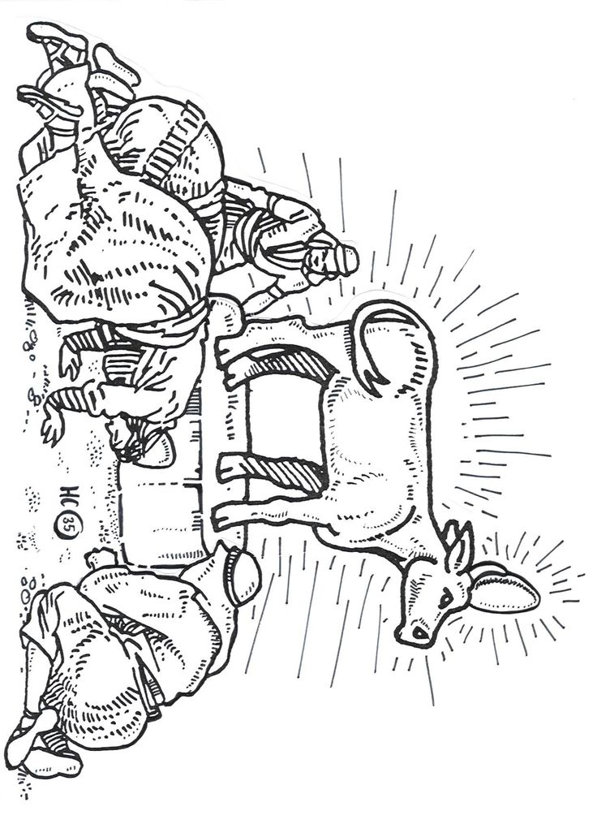

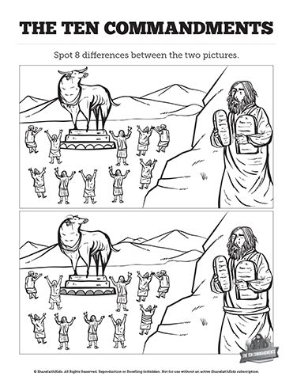

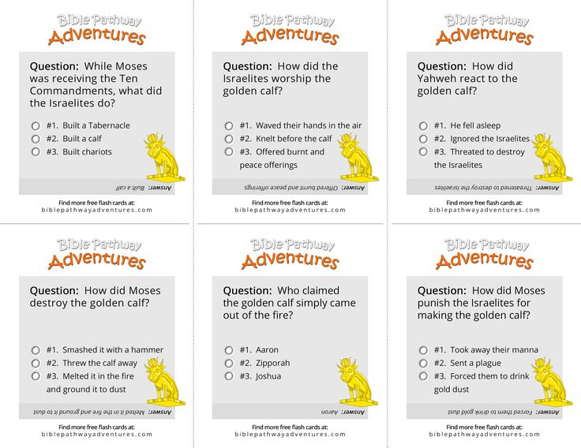

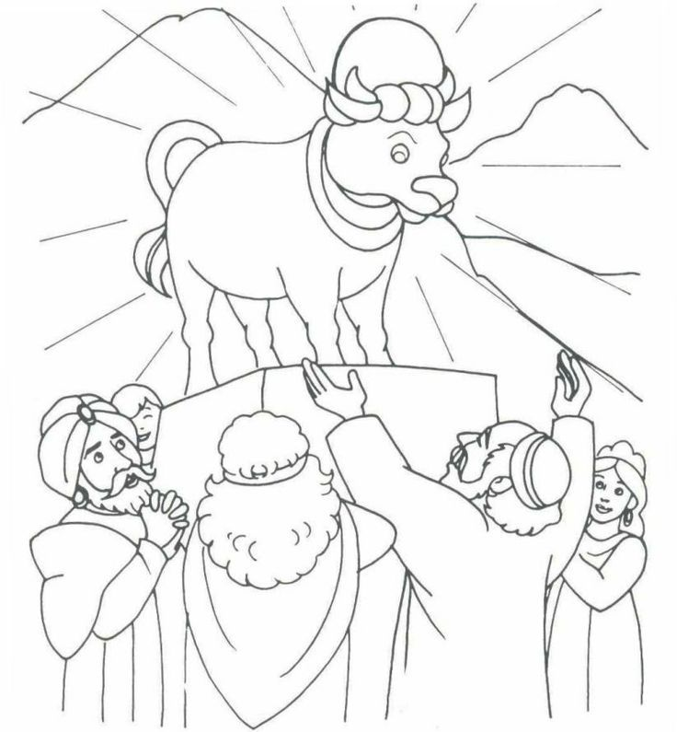

**Question & Answers**

* Who were the Israelites waiting for? (Moses to come down the mountain)
* How long was Moses gone? (40 days, see Exodus 24:18)
* What did Aaron use to make the golden calf? (gold earrings the people were wearing)
* How did Moses find out about the calf? (the Lord told him)
* What did Moses do when he came down from the mountain? (broke the two tablets with the ten commandments)
* What did Moses do to the golden calf? (burned it in the fire, ground it into powder, and made the people drink the water)
* Which commandment did the people break by making a golden calf? (Exodus 20:4) Look up the Bible reference and copy it below.
* The Israelites were tempted to worship something other than the one true God.
* What do you worship instead of God?

**Memory Verse**

*Trust in the Lord with all your heart and lean not on your own understanding; in all your ways submit to him, and he will make your paths straight.*

*Proverbs 3:5*-6

### **Art & Craft**

### **Gold Glitter calf**

Scripture **He took what they gave him and made it into a metal statue of a god. It looked like a calf. He shaped it with a tool. Exodus 32:4**



Supplies Calf coloring page, marker, glue, gold glitter

* Cover calf with glue.
* Sprinkle gold glitter onto calf
* Let glue dry.
* Write The Bible reference at the top of the paper. Exodus 32- The Golden Calf